Equal-Weighting and Bet Size Robustness
We also tested whether copying the original trader’s bet size is actually necessary for the strategy. Our original strategy assumes that larger anomalous bets contain more confidence or stronger private information, so we would match the trader’s position proportionally. However, this assumption may not hold because bet size can reflect a trader’s wealth, risk tolerance, or luck rather than better information. To test this, we compared equal-weighting, square-root weighting, and full dollar-weighting.
Equal-weighting means investing the same amount in every qualifying unusual bet, regardless of how large the original trader’s position was. Square-root weighting is an intermediate approach, where larger bets receive more capital, but not fully proportional to their size. Full dollar-weighting copies the original trader’s bet size directly.
For the corrected 1–20% signal set, equal-weighting produced a -38.8% ROI, square-root weighting produced a -39.0% ROI, and full dollar-weighting produced a -41.0% ROI. For the stricter 1–10% signal set, equal-weighting produced a -66.0% ROI, square-root weighting produced a -64.4% ROI, and full dollar-weighting produced a -63.7% ROI. Therefore, proportional dollar-weighting did not meaningfully improve performance. In the broader 1–20% range, it actually performed worse than equal-weighting.
This suggests that bet size alone is not a reliable proxy for private information. If larger bets reflected stronger informed conviction, then dollar-weighting should have allocated more capital to winning trades and improved returns. Instead, the winning trades did not receive meaningfully more dollar weight. In the 1–20% sample, winners made up 8.8% of trades under equal-weighting, but only 8.5% of capital under dollar-weighting. This means larger bets were not disproportionately concentrated on winning outcomes.
We also looked specifically at the upper tail of the bet-size distribution. The largest 10% of bets had a 3.5% win rate, the largest 5% had a 6.0% win rate, but the largest 2.5% and largest 1% had zero wins. This shows that while some moderately large bets performed better, the most extreme bets did not outperform. Therefore, the data does not support blindly increasing position size just because the original anomalous bet was larger.
Figure X shows the overall bet-size distribution and win rate by bet-size quintile. Most unusual bets are clustered near the $1,000 minimum threshold, while the upper tail contains only a small number of much larger bets. The win-rate confidence intervals overlap heavily across quintiles, showing that there is no clear statistical evidence that larger bets win more often.
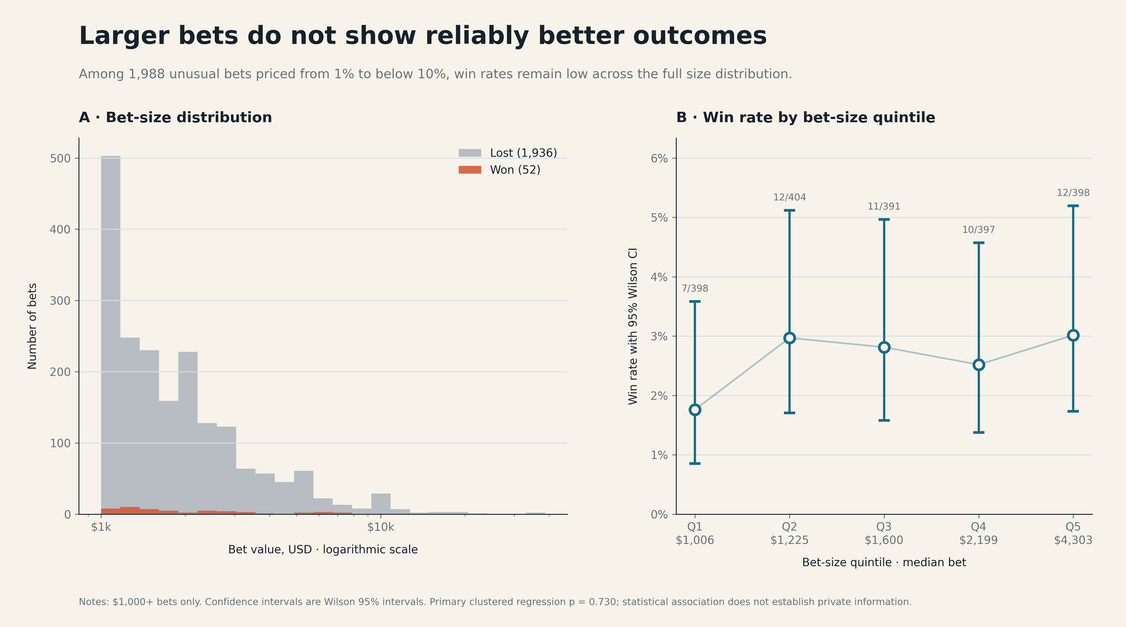
Figure X. Bet-size distribution and win rate by bet-size quintile.
Figure X focuses on the upper tail of the bet-size distribution. The observed win rate briefly increases in the largest 5% of bets, but falls to zero in the largest 2.5% and 1% groups. Since these tail groups have small sample sizes, the confidence intervals are wide, but the result still suggests that extreme bet size should not automatically be interpreted as stronger information.
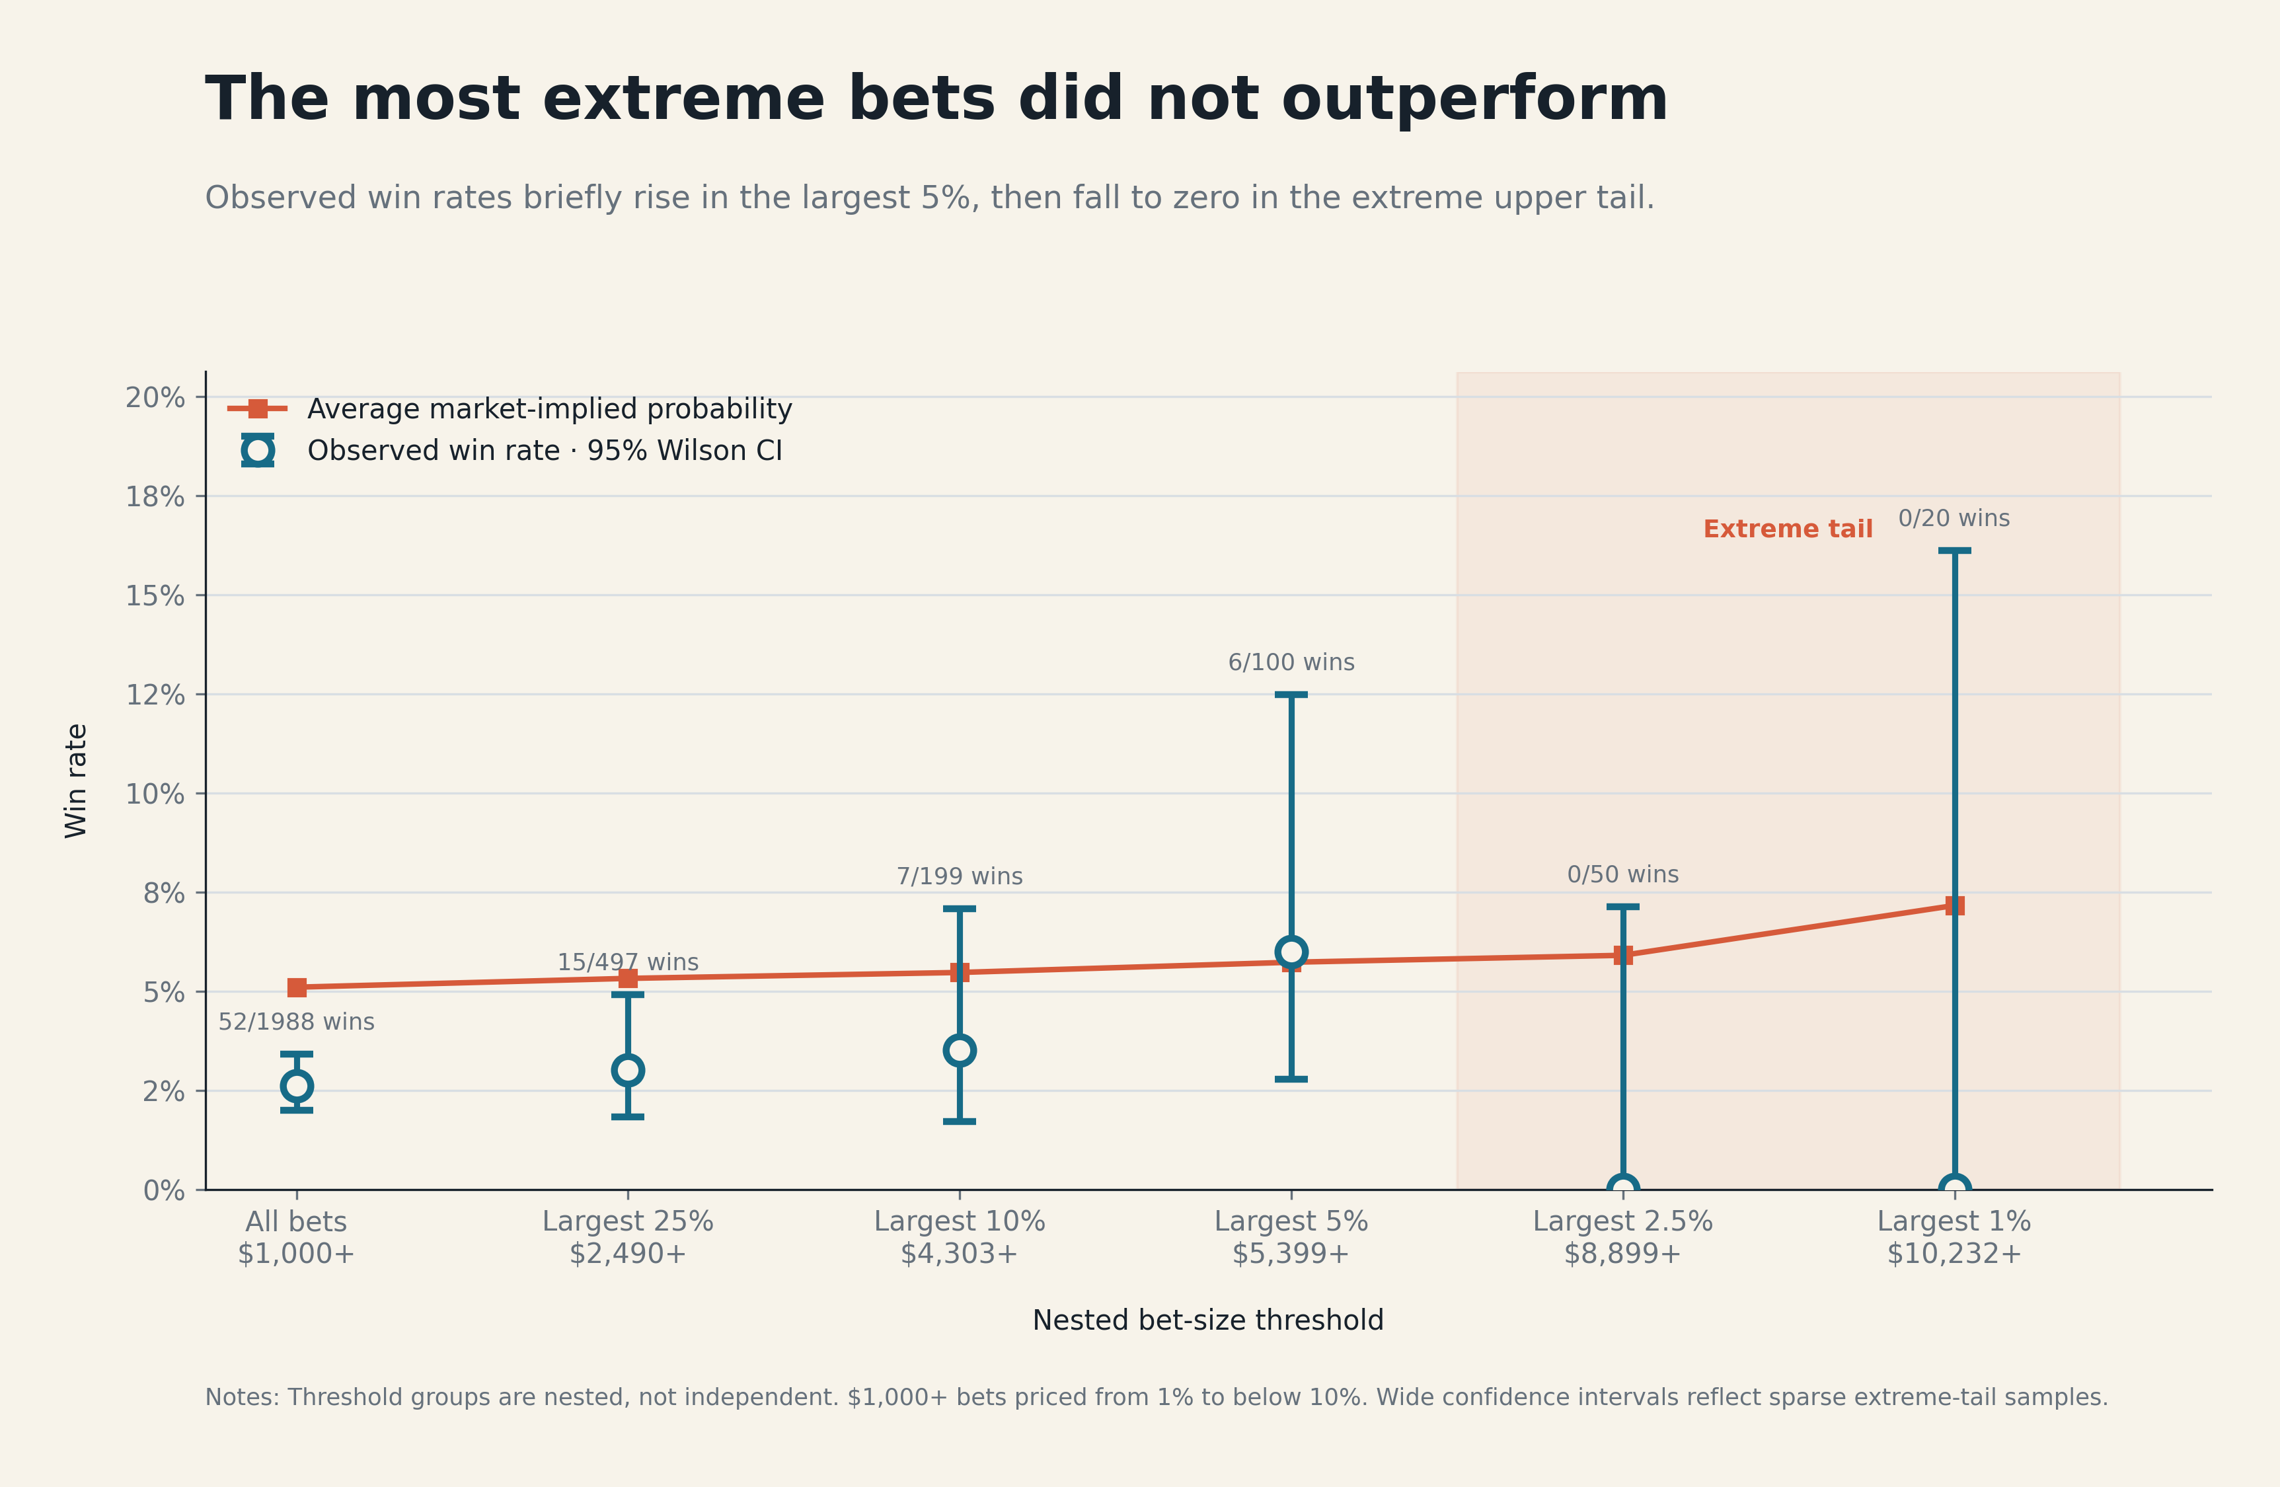
Figure X. Upper-tail bet-size thresholds and observed win rates.
Overall, equal-weighting shows that our strategy should not rely only on copying bet size. Future versions of the strategy should instead identify which events, categories, geographies, or wallets are more reliable, and then use bet size as a secondary signal rather than the main sizing rule.

